MRPI®/EPD VERIFICATION PROTOCOL MAy 2017,

verification checklist, DIALOGUE DOCUMENT

May 2017, v3.0: FINAL

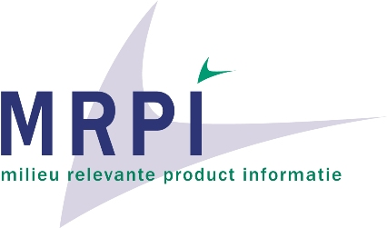

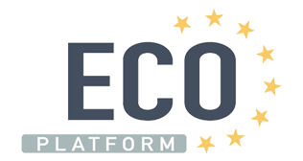

Stichting MRPI®
Zuid Hollandlaan 7
2596 AL Den Haag
The Netherlands
janpieter@MRPI.nl
Tel: +31 (0)6 22 97 20 56

Example of dialogue between verifier/Program Operator and EPD owner / practitioner during the verification process
Any deviations from the requirements should be reported by the verifier, and the dialogue between verifier and LCA practitioner should be made transparent as well improvements made following the verification process. This can be done separate from the checklist. The format to do so is free to choose. Examples are given below:

Example:
Issue number | Question / comment | response

Example (partly based on XP TS14071)

Comment N° | Chapter Article  Paragraph | Alinea  Table | Type of comment (Ed, Te, Ge) | Ref. to a Eco check list (or program rules) section | Verifier comment and recommendation | EPD owner / LCA practitioner answer | Final verifier statement

